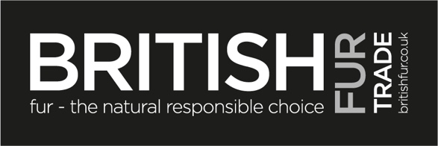

UK FUR SECTOR STATEMENT ON DANISH MINK SITUATION
It’s clear that events in Denmark are moving fast and everything must be done to put public health first. Even though the full science is not clear, the Danish government has acted swiftly and on the side of caution.

The Danish Government also confirms that the variants discovered are not found to pose a greater risk to humans than the known SARS-CoV2 virus. Indeed, the British Prime Minister’s Spokesman said on Friday 6th November : “While there have been some rare reports of mink to human transmission within mink farms, we do not consider this a risk to the UK, where, obviously, there are no fur farms, but we are keeping the situation under close review.”

The strategy to temporarily eliminate mink production in Denmark seeks to make sure the mink farm variants will not establish itself in first Danish, then international societies. The Danish Government are keeping the European Centre for Disease Control, the World Health Organisation and the European Commission updated in accordance with relevant, international health protocols.

It’s hoped that the detailed science will become clear soon and indeed will be valuable to all farming sectors. In the meantime, the WHO has said that they want to get more details and opinions before they make any statements.

It is important to stress that the temporary measure to cull mink in Denmark is not an anti-fur position. Indeed, there is no plan to phase out mink farming in Denmark. The Danish Government fully supports fur farming and will be compensating the farmers who have seen their livelihoods wiped out overnight. Animal welfare and assurance schemes in Denmark are the gold standard for animal husbandry.

Mink farming continues in other countries around the world and the farming community has already put in place extensive bio security measures. Other fur types such as fox and wild fur are not impacted by the virus.

Fur in the UK is popular with a third of British households owning an item of fur and sales have increased by nearly 200 per cent in the last few years particularly among young age groups who reject synthetic fast fashion in favour of sustainable, natural materials.

Finally, it is disappointing that there are some who oppose the fur sector in the UK who are now seeking to capitalise on this regrettable episode for their own purposes and have made certain inaccurate and misleading claims. The situation calls for facts, evidence and science not mistruths and scaremongering.

